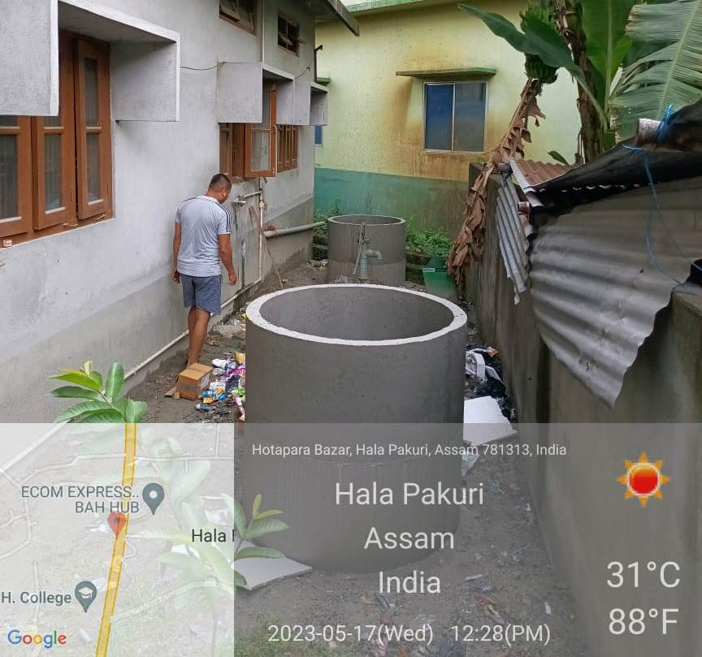
Concrete waste dustbin set up in Women’s Hostel, B. H. College Howly
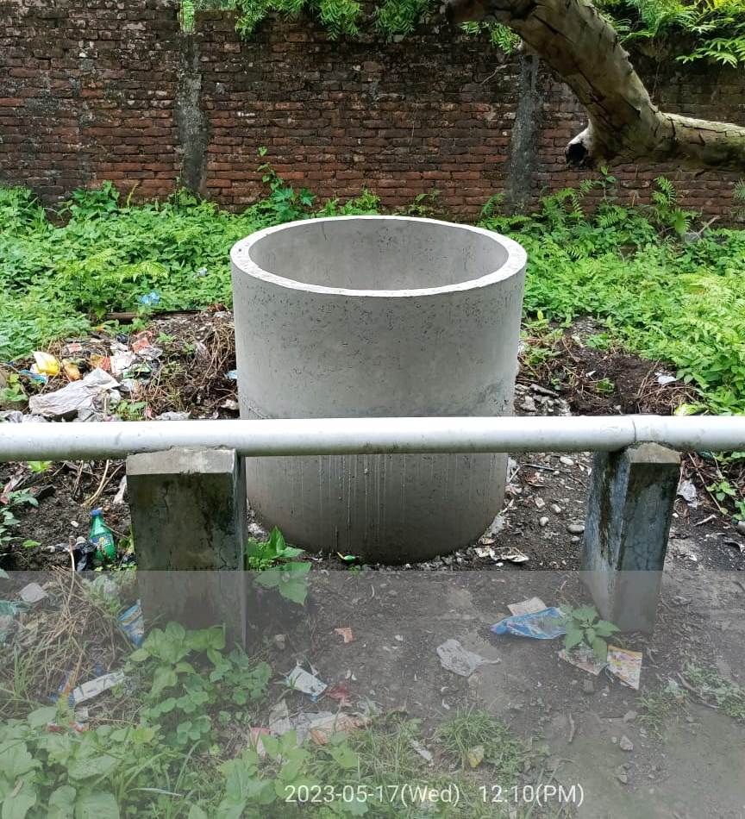
Concrete waste dustbin set up in Men’s Hostel, B. H. College Howly
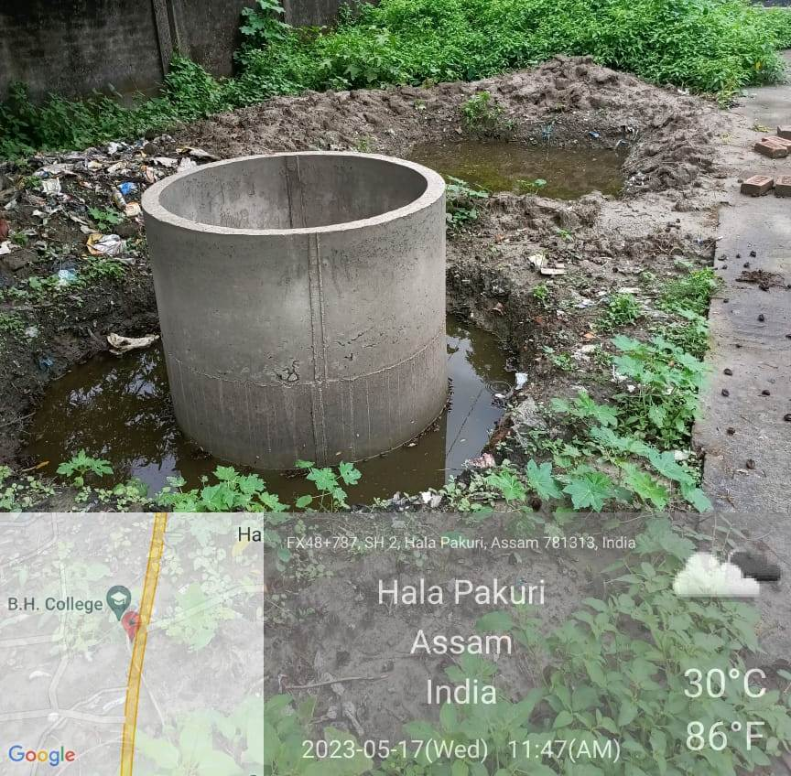
Waste dustbin set up in College Canteen
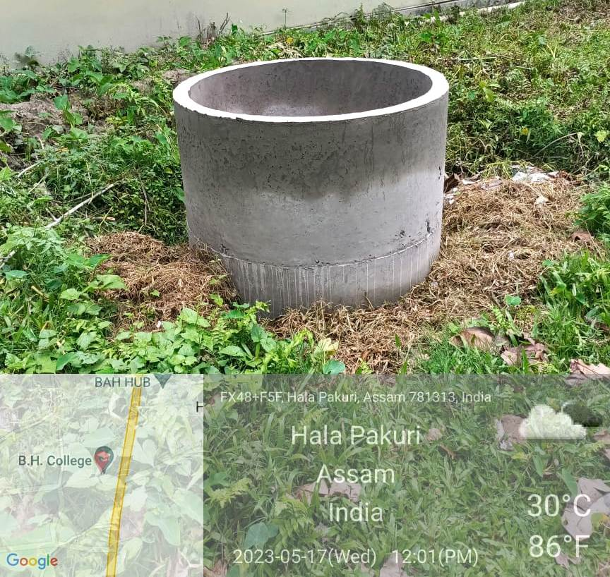
Concrete Waste Dustbin Set up in Guest House. B.H. College, Howly

